**Capstone Project Concept Note and Implementation Plan**

**Title: Real-Time Recycling Sorting Using Deep Learning**

**Group no: Group 8**

**Group Members:**

1. Tekia Tekle

2. Firehiwet Zerihun

3. Biniyam Demissew

4. Daniel Alemu

5. Eyob Sisay

6. Haymanot Tamrat

# Concept Note

## Project Overview

This project addresses the inefficiency of manual waste sorting by introducing a real-time, deep learning-based image recognition system. It supports **SDG 11 (Sustainable Cities and Communities)**, **SDG 12 (Responsible Consumption and Production) and SDG 13 (Climate Action)** by promoting effective recycling through automation. Traditional waste sorting is labor-intensive and often inaccurate, which leads to high contamination rates. This project proposes an AI-powered approach that increases efficiency, accuracy, and scalability in sorting recyclable materials (1) (2).

## Objectives

* To Design and develop a real-time object detection system
* To Enhance the accuracy and efficiency of recycling
* To Deploy an AI-powered waste sorting solution
* To Reduce dependency on manual waste segregation
* To Promote sustainable waste management practices

## Background

Urban waste sorting systems continue to face challenges such as labor shortages, contamination of recyclables, and inconsistent sorting efficiency. In recent years, **deep learning** has emerged as a reliable solution for automating the identification of recyclable materials by analyzing visual features. For instance, the **TrashNet dataset** by Thung and Yang (2016) provides labeled waste images used to train classification models based on convolutional neural networks (CNNs) (1). Additionally, the **YOLO (You Only Look Once)** framework introduced by Redmon et al. (2016) enables high-speed object detection in real time, making it a practical choice for automated recycling systems (2). More recently, researchers demonstrated deep learning models capable of classifying waste types using real-world image data, validating the feasibility of intelligent sorting technologies (3) . These contributions collectively form the technological backbone for building scalable and efficient recycling systems using AI.

## Methodology

We will employ **YOLOv5/YOLOv8** for real-time object detection and classification. The pipeline will process a continuous video stream from a camera and detect waste types (plastic, paper, glass, etc.). CNN architectures will be trained with augmented datasets using transfer learning. The key steps include data collection, preprocessing, model training, validation, and deployment to a low-resource device.

## Architecture Design Diagram

**System Components:**

* **Camera Input** – Captures real-time waste images.
* **Preprocessing Module** – Normalizes input for the model.
* **YOLO Model** – Detects and classifies the waste.
* **Decision Engine** – Maps detection output to an actuator.
* **Hardware Control** – Sorts items to respective bins.

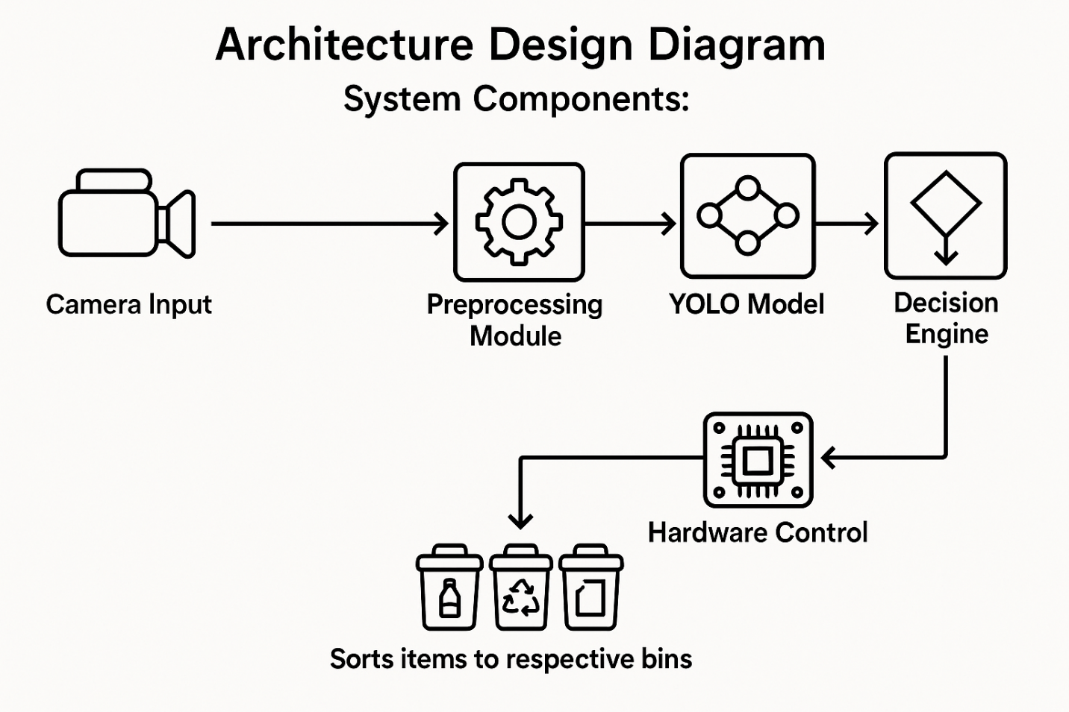

**6. Data Sources**

We will use:

* **TrashNet Dataset** – Images of six waste categories (1).
* **Dry/Wet Waste Dataset on Roboflow** – Object detection format (4).
* **Kaggle Waste Classification Dataset** – Recyclable vs organic waste (5).

All datasets will be augmented using brightness variation, noise, rotation, and flipping to simulate real-world scenarios.

## Literature Review

Redmon et al. (2016) (2) demonstrated a smart classification model for waste using CNNs. YOLO by Redmon et al. (2016) (2)allows real-time performance, ideal for on-site deployment. MobileNetV2 (6) and EfficientNet (7)offer efficient alternatives for edge devices. These studies confirm that deep learning is a powerful tool for scalable, intelligent recycling.

# Implementation Plan

## Technology Stack

* **Programming Language**: Python
* **Libraries**: PyTorch, TensorFlow, OpenCV, NumPy
* **Tools**: Google Colab, Jupyter Notebook

## Timeline

|  |  |  |
| --- | --- | --- |
| Task | Week | Resposible |
| Literature Review | Week 1 | Member 1&2 |
| Data Collection & Cleaning | Week 2 | Member 3&4 |
| Model Design and Training | Week 3-4 | All |
| Real-Time Testing & Refinement | Week 5 | All |
| Final Report & Presentation | Week 6 | All |

## Milestones

* Dataset selection & preprocessing completed
* Trained model achieves >85% accuracy
* Final project submission and documentation

## Challenges and Mitigations

|  |  |
| --- | --- |
| Challenge | Mitigation |
| Class imbalance | Data augmentation and weighted loss |
| Real-time latency | Use of MobileNet-based YOLO on edge device |
| Poor lighting/environment noise | Use diverse training images & filters |

## Ethical Considerations

* **Bias**: Ensuring balanced data across all waste types
* **Privacy**: No personal data collected
* **Social Impact**: Designed to support not replace workers

# References

1. **Yang, Thung and.** kaggle. *Trashnet.* [Online] 2016. https://www.kaggle.com/search?q=TrashNet.

2. *You Only Look Once: Unified, Real-Time Object Detection. .* **Redmon, J., Divvala, S., Girshick, R., & Farhadi, A.** 2016, In Proceedings of the IEEE Conference on Computer Vision and Pattern Recognition (CVPR)., pp. 779–788.

3. *Intelligent waste management: a comprehensive review of machine learning and deep learning applications in advanced recycling.* **Adiba Tabassum Chowdhury, Muhammad E.H. Chowdhury, Md. Sakib Bin Islam, Mehrin Newaz, Abdus Salam, Faizul Sayem, Mazhar Hasan-Mia, Mohammad Nashbat, Molla Ehsanul Majid, Amith Khandakar, Saad Bin Abul Kashem, Azad Ashraf.** [ed.] Nebojsa Bacanin, Jaehwan Kim, Neha B Vashisht,Harnessing Automation and Machine Learning for Resource Recovery and Value Creation,Elsevier Kishor Kumar Sadasivuni. 2025.

4. **Kinge, Bhushan.** Dry and Wet Waste Dataset. *roboflow2020drywet.* [Online] 2020.

5. **Recycling Waste Classification Dataset. *kaggle.* [Online] 2021. https://www.kaggle.com/datasets/techsash/waste-classification-data.**

**6. *MobileNetV2: Inverted Residuals and Linear Bottlenecks.* Sandler, Mark and Howard, Andrew and Zhu, Menglong and Zhmoginov, Andrey and Chen, Liang-Chieh. 2018.**

**7. *EfficientNet: Rethinking Model Scaling for Convolutional Neural Networks.* Le, Mingxing Tan and Quoc V. 2019.**

**8. *Revolutionizing urban solid waste management with AI and IoT: A review of smart solutions for waste collection, sorting, and recycling,Results in Engineering.* Lakhouit, Abderrahim. 2025, Vol. 25.**

**9. *Waste image classification based on transfer learning and convolutional neural network,Waste Management.* Qiang Zhang, Qifan Yang, Xujuan Zhang, Qiang Bao, Jinqi Su, Xueyan Liu. 2021, Vol. 135, pp. 150-157.**

**10. *Turning trash into treasure: Exploring the potential of AI in municipal waste management - An in-depth review and future prospects,.* Asmae El jaouhari, Ashutosh Samadhiya, Anil Kumar, Eyob Mulat-weldemeskel, Sunil Luthra, Rajesh Kumar. 2025, Vol. 373.**

**11. Tomra’s AI-powered sorting technology: Revolutionizing recycling: Revolutionizing recycling. [Online] 2023. https://www.tomra.com.**

**12. *Artificial intelligence based classification for waste management: A survey based on taxonomy, classification & future direction.* Dhanashree Vipul Yevle, Palvinder Singh Mann,Artificial intelligence based classification for waste management:. 2025, Vol. 56.**